Assessment Brief- Weekly Progress Report - Individual

Cybersecurity Capstone Project: Weekly Progress Report Week 7

Student Information
- Student Name: Prashan Manandhar
- Student ID: CIHE 241182
- Project Title: Creditcard Fraud Detection using ML
- Supervisor Name: Md Ashraf Uddin
- Week Number: 07 / 09
- Date of Submission: 29/04/26

1. Introduction
This part of the project focused on moving the credit card fraud detection system from model development into system implementation. After completing the machine learning and deep learning model comparison, the next step was to deploy the selected model as a working backend service. The purpose of this stage was to demonstrate how the fraud detection model can be used in a real-world financial system through an application programming interface.
2. API Prototype Implementation

A FastAPI backend was developed to expose the trained fraud detection model as a service. The final Enhanced Random Forest model and scaler were saved as reusable files and loaded into the backend. This allows the system to accept transaction feature input, process it using the same scaling method used during training, and return a fraud prediction.

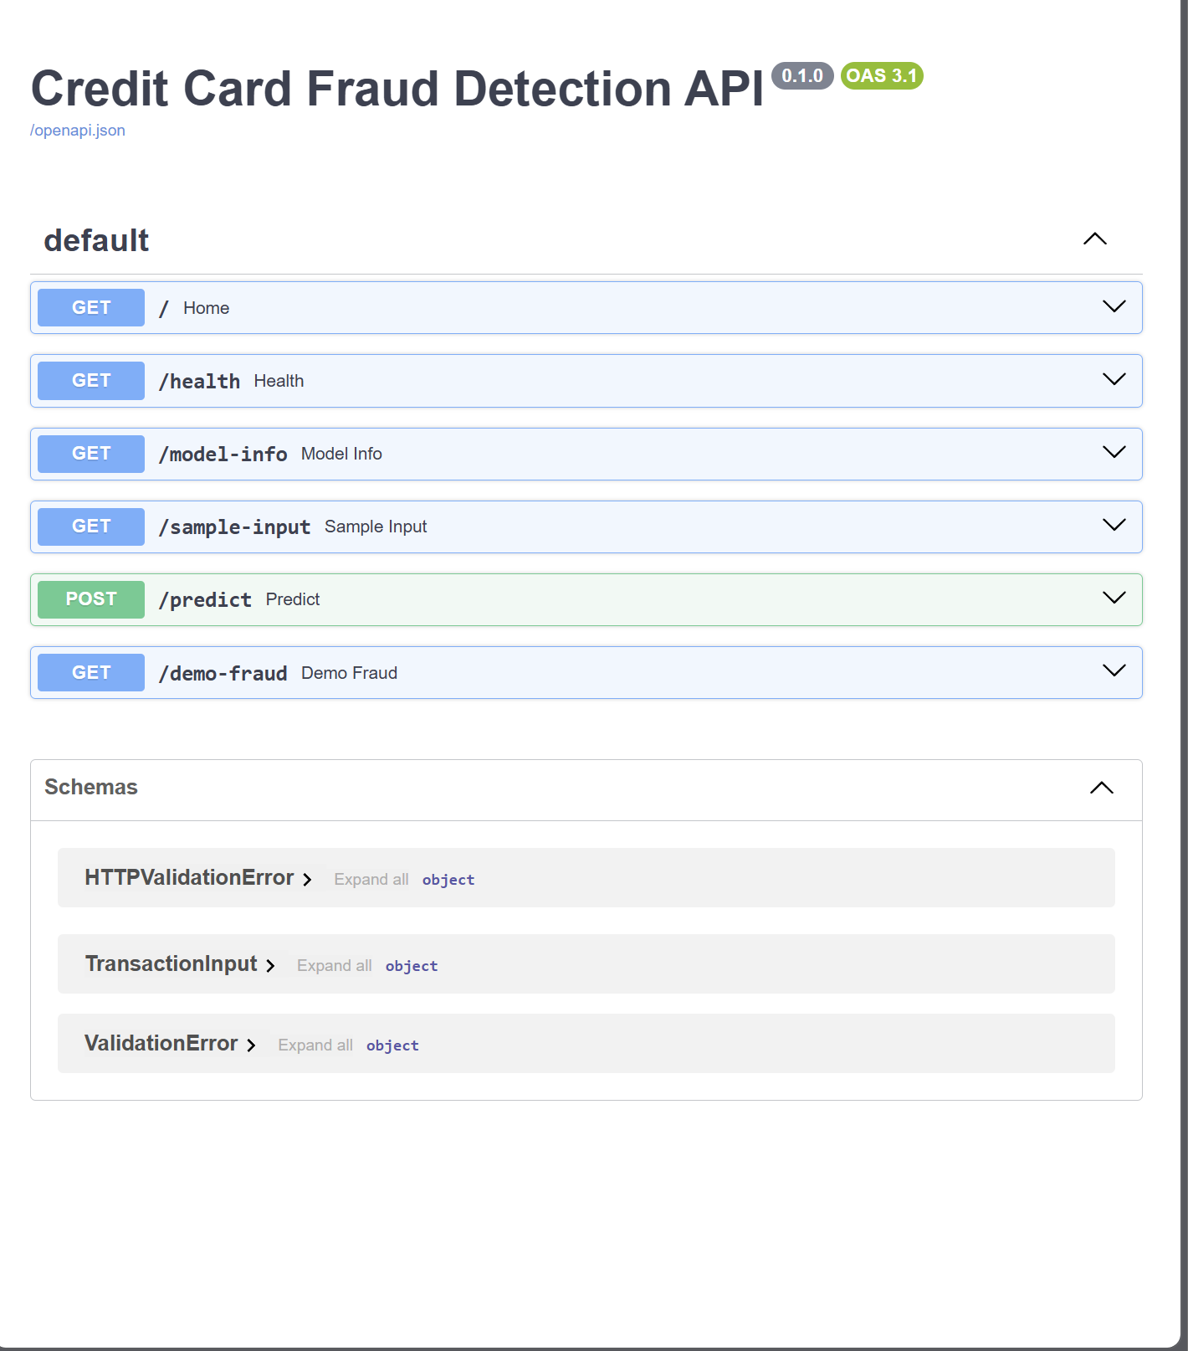

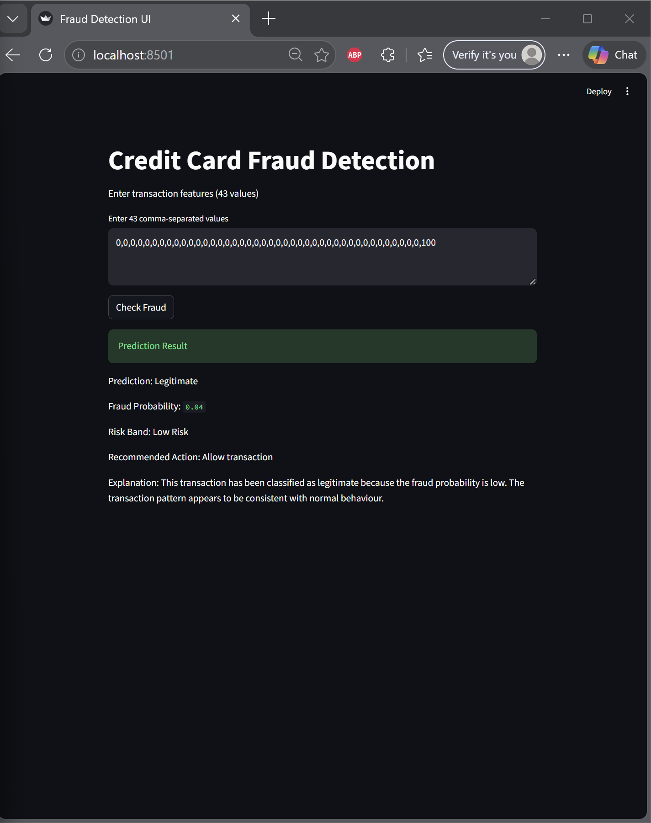

3. API Endpoints Developed

Several endpoints were created to support the fraud detection workflow. The health endpoint checks whether the service is running correctly. The model information endpoint displays details about the deployed model, including the expected number of input features. The sample input endpoint provides the correct input format for testing. The prediction endpoint accepts transaction data and returns the fraud prediction, fraud probability, risk band, recommended action, and explanation.
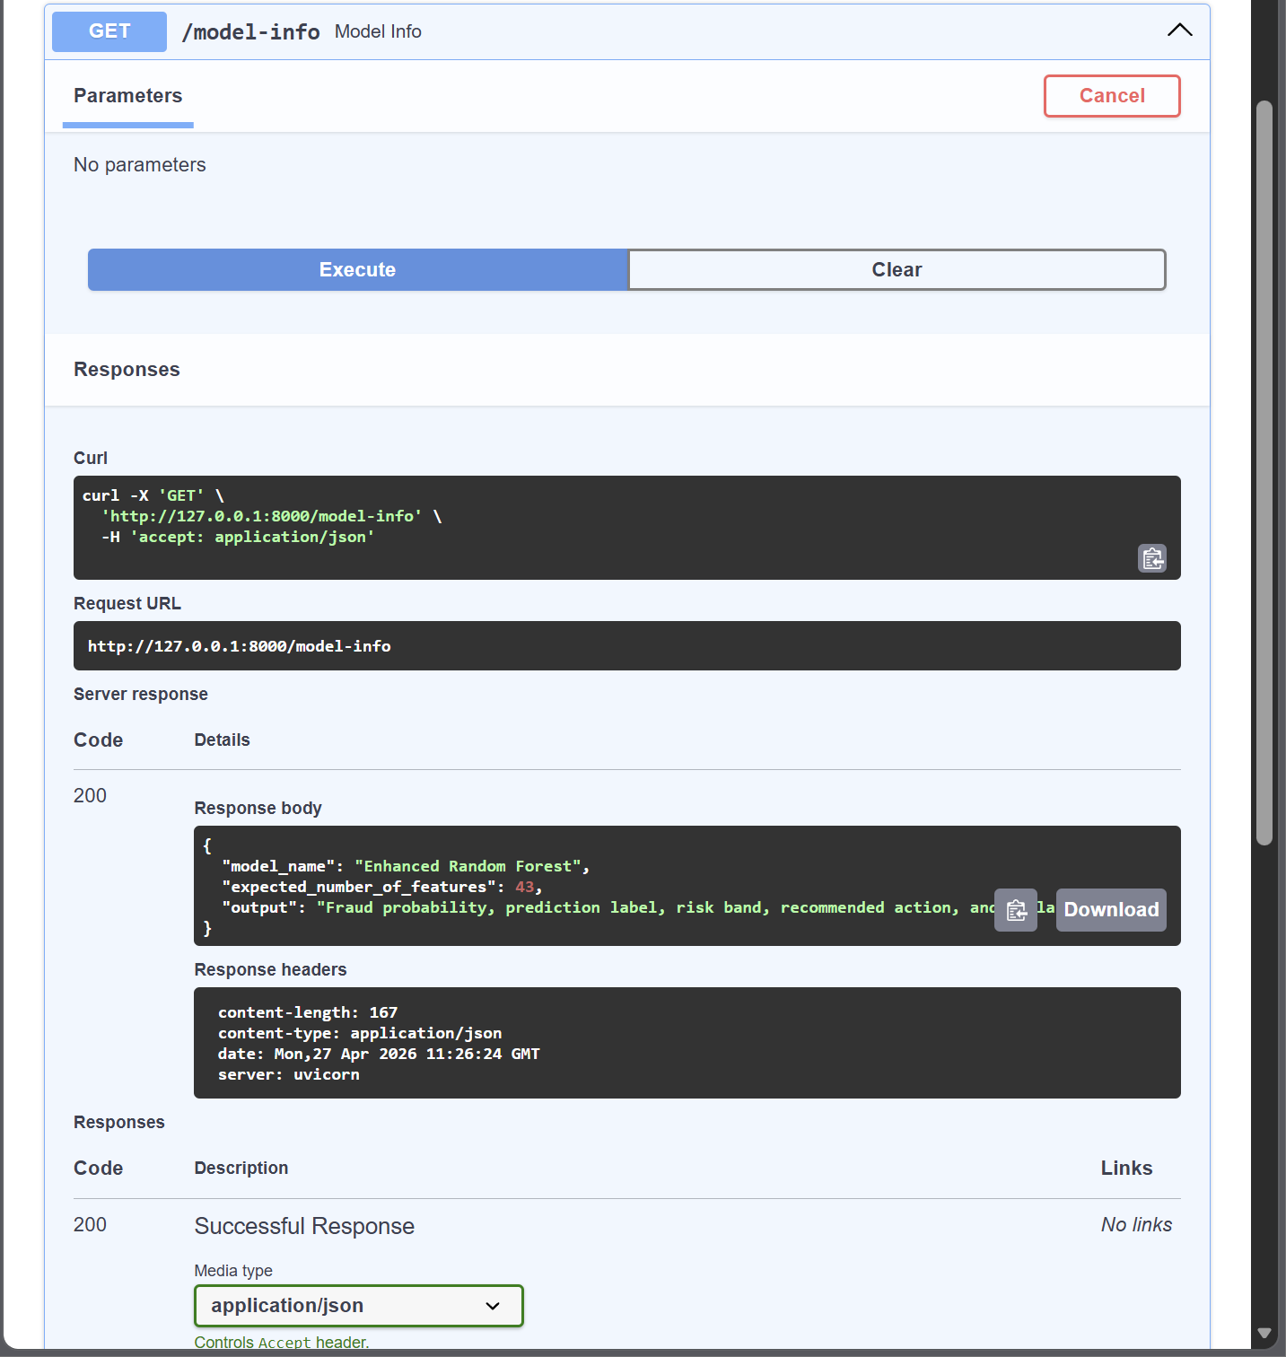

4. Real-Time Fraud Prediction

The prediction endpoint was successfully tested using Swagger. The system accepted a transaction input and returned a prediction result. The output included whether the transaction was legitimate or fraudulent, the fraud probability, the risk category, and the recommended action. This shows that the trained model can now be used outside the notebook environment.

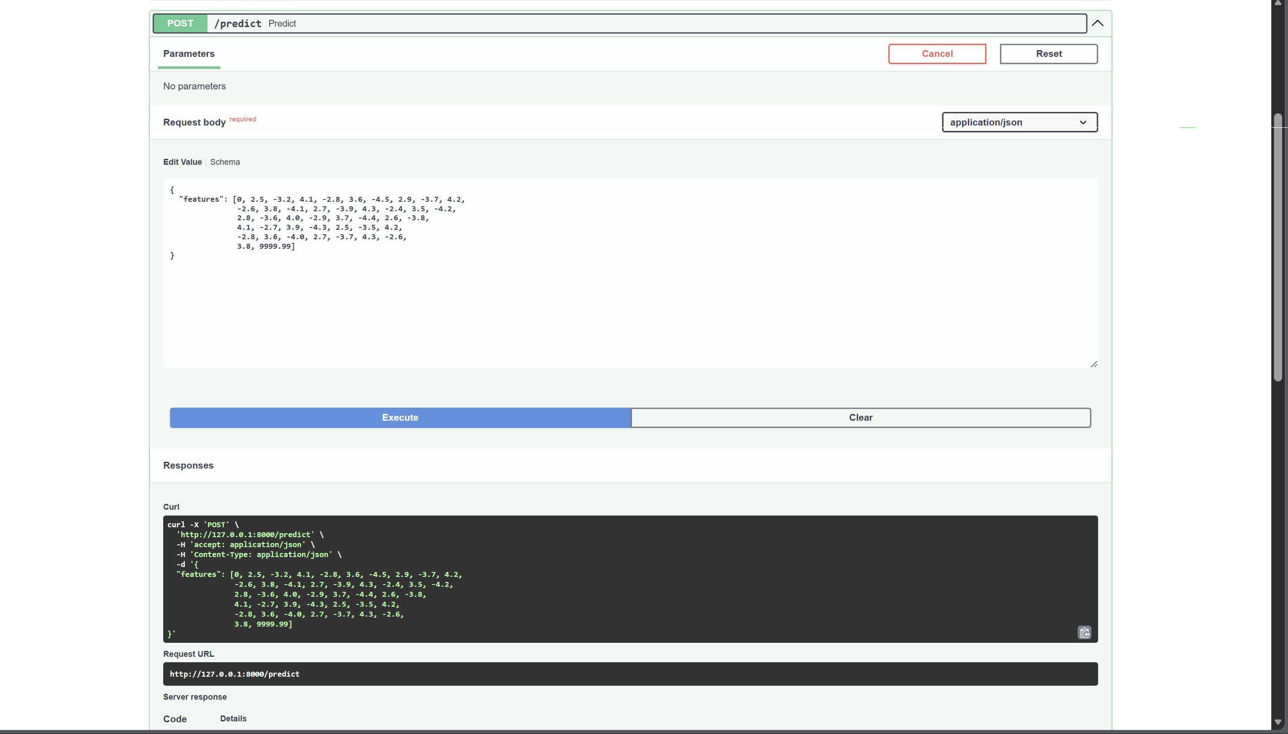

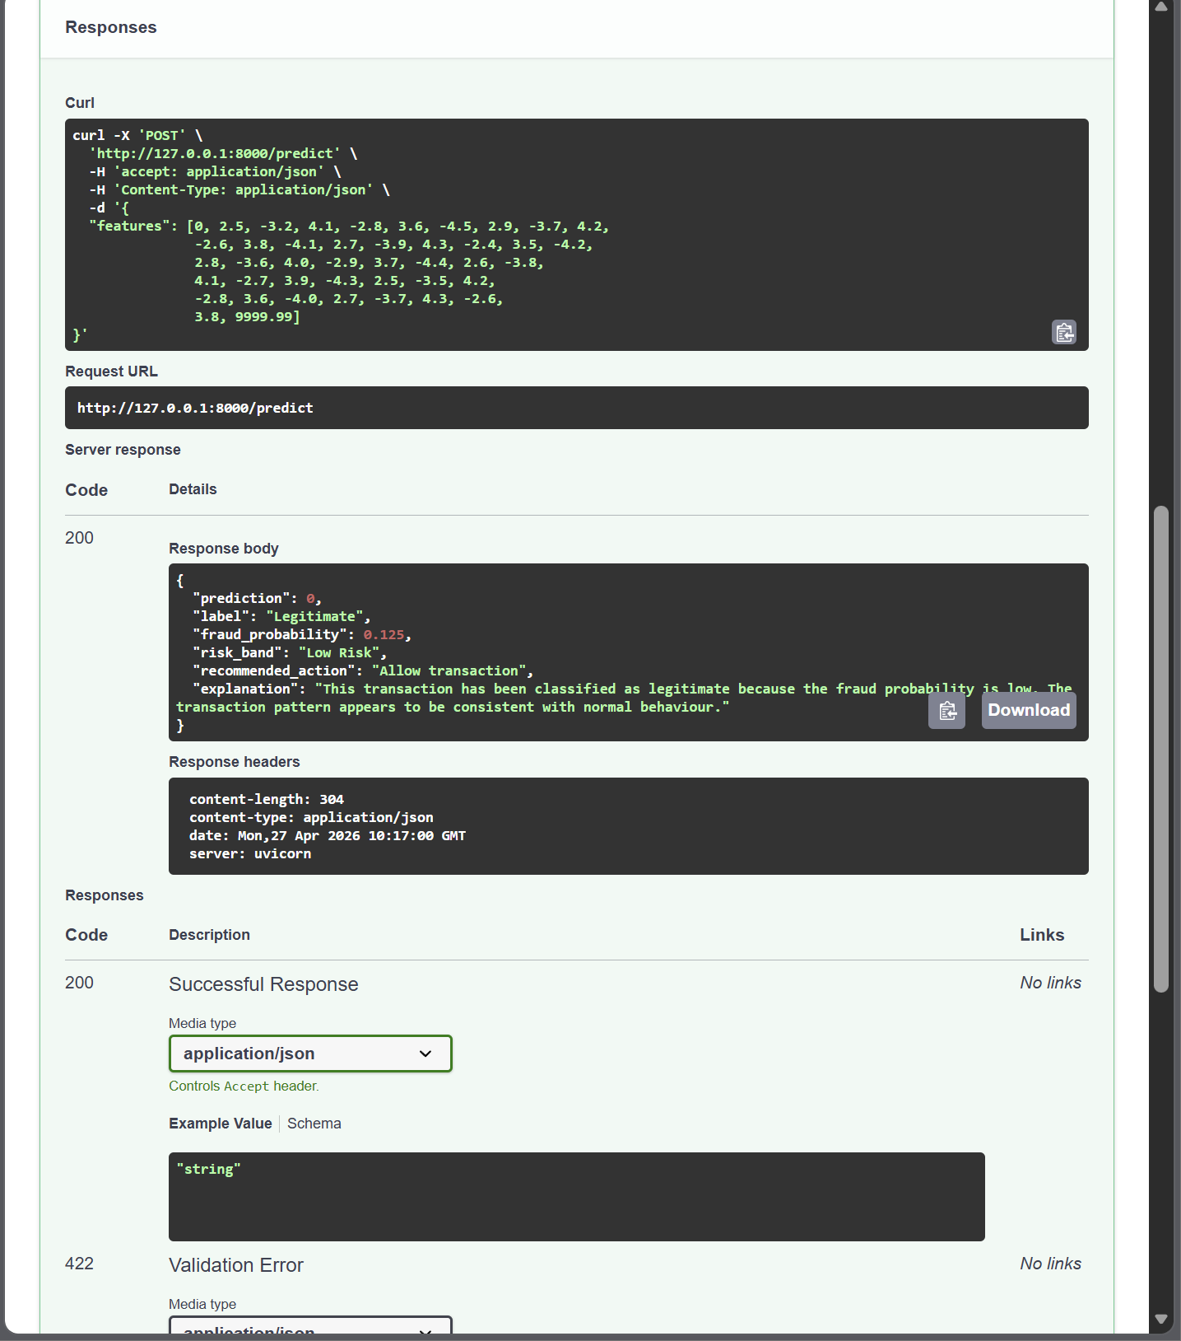
5. Explanation and Decision Support
The API was improved to provide more than just a prediction result. It now includes a simple explanation layer and recommended action. This makes the system more useful for real-world decision making because users can understand why a transaction is considered low risk, medium risk, or high risk. This explanation layer also prepares the system for future integration with a large language model such as Google Gemini.

6. Fraud Demonstration Endpoint

A demonstration endpoint was added to show how the system would respond to a high-risk fraudulent transaction. This endpoint is useful for presentation purposes because manually created test values may not always trigger a fraud result from the trained model. The demonstration endpoint clearly shows the expected response format for a high-risk fraud case.
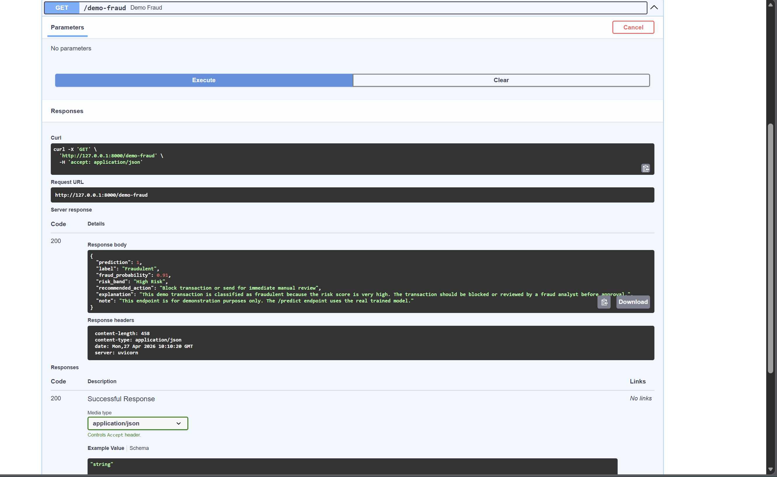

7. Relevance to Financial Institutions

This API-based design is suitable for financial institutions because banks and payment systems commonly use backend services to connect different applications. In a real-world scenario, a payment gateway, mobile banking system, or fraud monitoring dashboard could send transaction data to this API and receive an immediate fraud risk result. The returned prediction, probability, risk band, and recommended action can support decisions such as approving, blocking, or manually reviewing a transaction.

8. Remaining Work

The next step is to connect the FastAPI backend with a graphical Streamlit interface. This will allow users to enter transaction details through a dashboard instead of directly using Swagger. The explanation layer can also be enhanced by integrating a large language model such as Google Gemini to generate more natural and dynamic explanations. Other future improvements include database logging, user authentication, role-based access control, and model monitoring.

9. Weekly Progress Summary

This stage successfully converted the trained fraud detection model into a working backend prototype. The system now supports real-time fraud prediction through FastAPI and returns useful decision-support outputs, including probability, risk band, recommended action, and explanation. This marks a major step toward building a complete LLM-assisted credit card fraud detection and explanation platform.

10. Graphical User Interface Prototype

A simple Streamlit user interface was developed and connected to the FastAPI backend. This allows users to enter transaction feature values through a web interface instead of using Swagger directly. When the user submits the transaction, the interface sends the data to the backend API and displays the prediction, fraud probability, risk band, recommended action, and explanation.
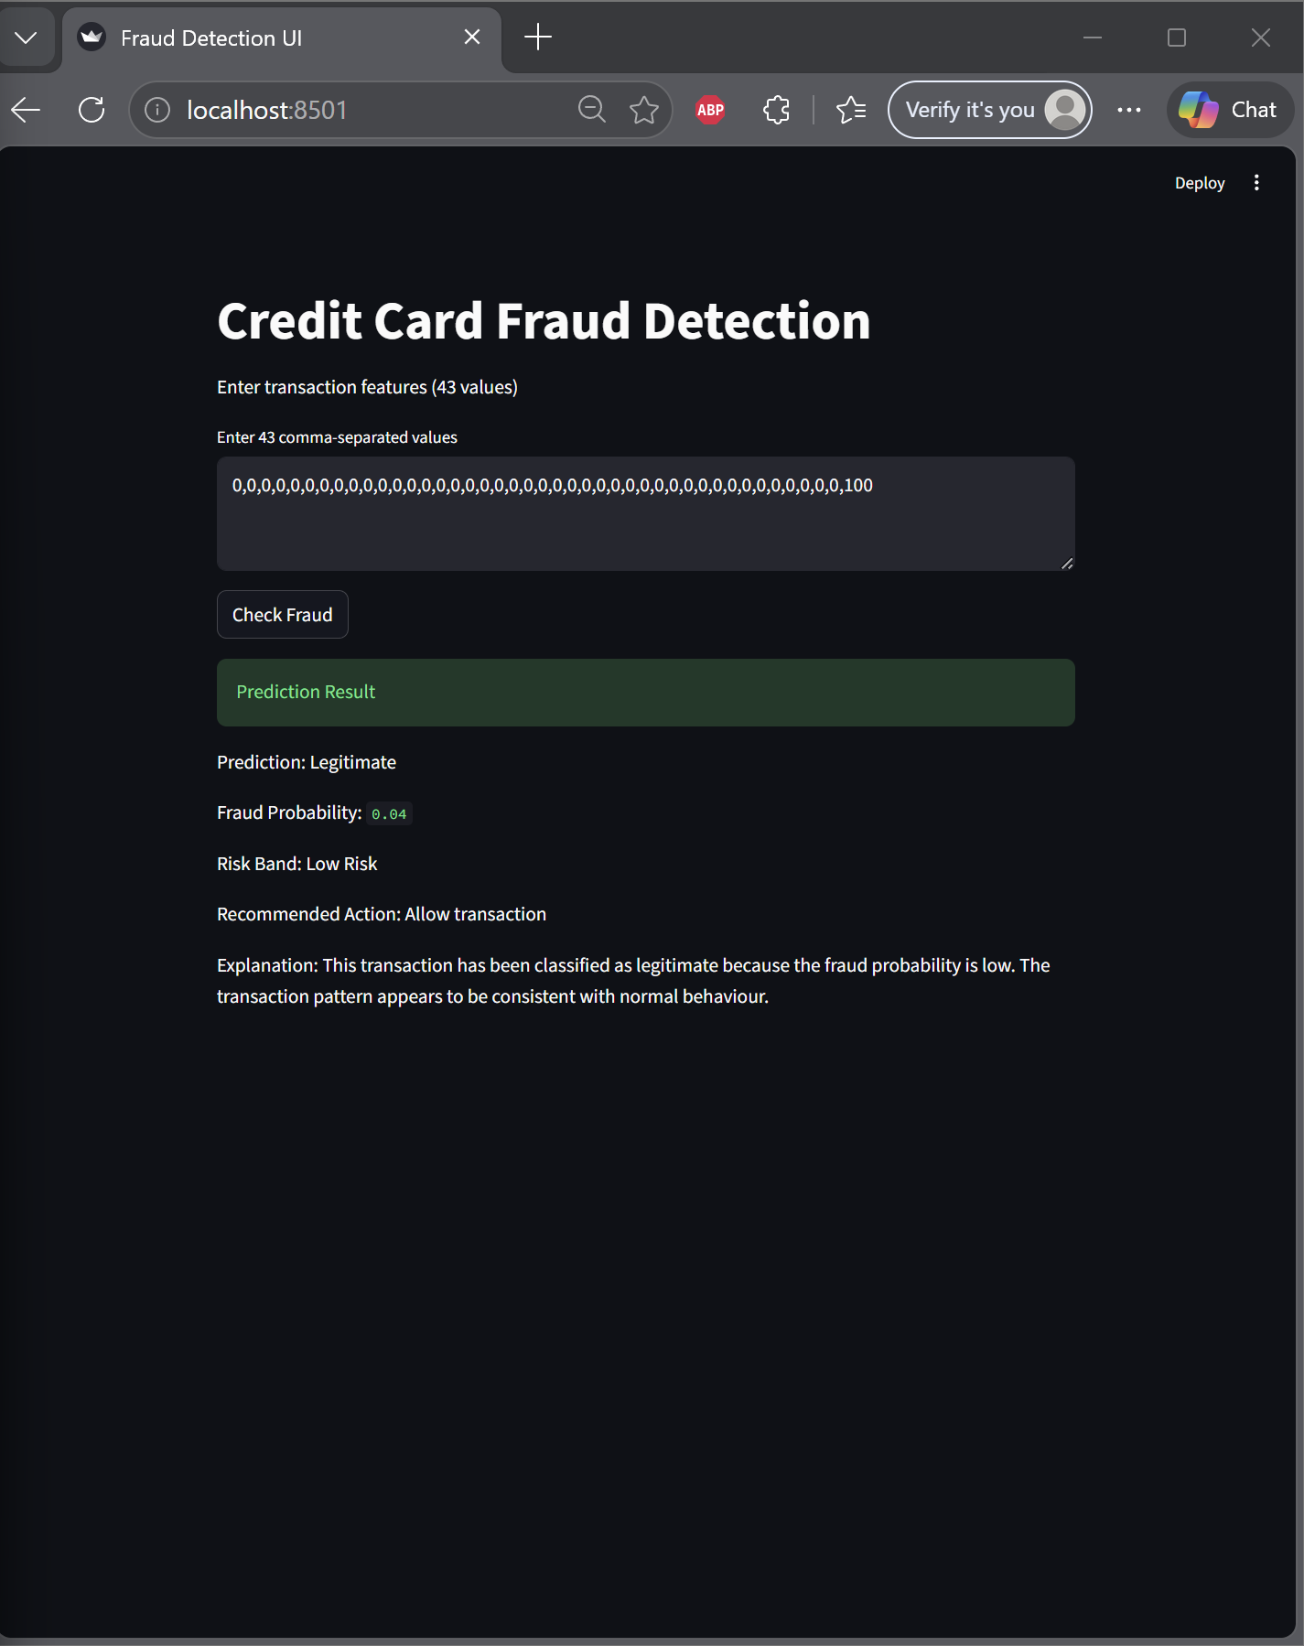

7. Progress Status Checklist

Task | Completed? (Yes/No) | Comments
Implemented planned functions/modules | _Yes | __ FastAPI backend with multiple endpoints developed
Addressed supervisor feedback | __Yes | __ Added anomaly models and explanation layer
Tested implemented features | Yes | __ Tested via Swagger interface successfully
Updated documentation | Yes | __ Weekly report updated with implementation details
Identified next week’s tasks | Yes | __ Streamlit UI and LLM integration planned

Student Signature: _______________

Supervisor Comments (Optional):
- Generate an additional 500 synthetic fraud transactions using AI.
- Add these synthetic fraud transactions to the original dataset and prepare the final training dataset.
- Send me the dataset links you are using, including:
  - the original dataset link
  - the updated dataset link after adding the synthetic fraud transactions
- Train the machine learning model again using the updated dataset.
- Apply and compare different ensemble learning techniques, including:
  - Bagging
  - Boosting
  - Stacking
- Continue working on the graphical user interface (GUI) and integrate the trained model into the system.

Supervisor Signature: _______________

